Day 15 — UDF Practice

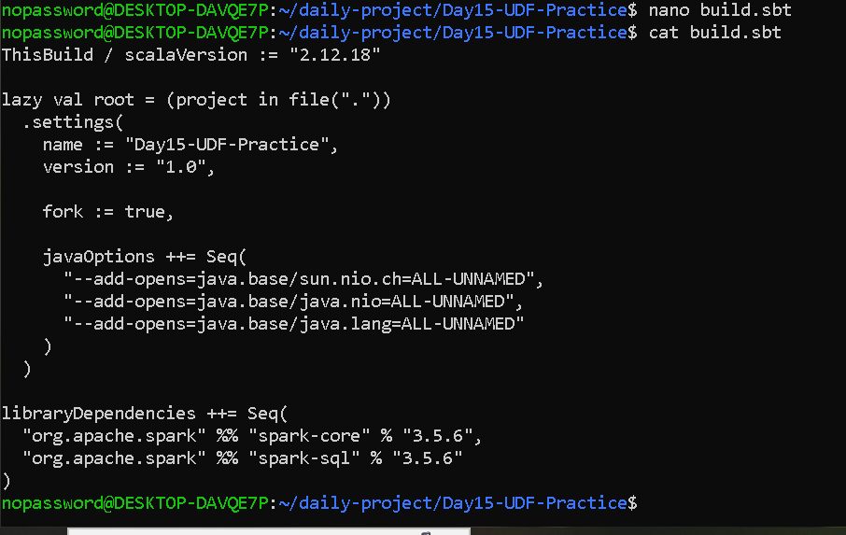

Create SalaryUDF.scala
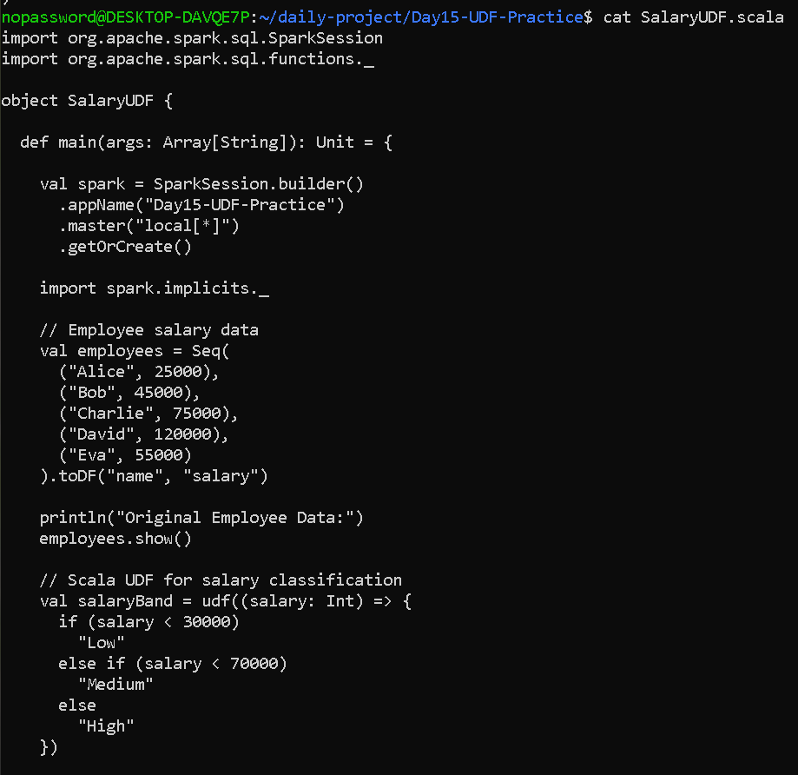
nano SalaryUDF.scala
import org.apache.spark.sql.SparkSession
import org.apache.spark.sql.functions._

object SalaryUDF {

def main(args: Array[String]): Unit = {

val spark = SparkSession.builder()
.appName("Day15-UDF-Practice")
.master("local[*]")
.getOrCreate()

import spark.implicits._

// Employee salary data
val employees = Seq(
("Alice", 25000),
("Bob", 45000),
("Charlie", 75000),
("David", 120000),
("Eva", 55000)
).toDF("name", "salary")

println("Original Employee Data:")
employees.show()

// Scala UDF for salary classification
val salaryBand = udf((salary: Int) => {
if (salary < 30000)
"Low"
else if (salary < 70000)
"Medium"
else
"High"
})

// Add calculated column using withColumn
val result = employees.withColumn(
"salary_band",
salaryBand(col("salary"))
)

println("Salary Classification using UDF:")
result.show()

// Built-in Spark function comparison
val builtInResult = employees.withColumn(
"salary_band",
when(col("salary") < 30000, "Low")
.when(col("salary") < 70000, "Medium")
.otherwise("High")
)

println("Salary Classification using Built-in Function:")
builtInResult.show()

// Register UDF with Spark SQL
spark.udf.register("salary_band_udf", (salary: Int) => {
if (salary < 30000)
"Low"
else if (salary < 70000)
"Medium"
else
"High"
})

// Create temporary view
employees.createOrReplaceTempView("employees")

// Use registered UDF in Spark SQL
val sqlResult = spark.sql("""
SELECT
name,
salary,
salary_band_udf(salary) AS salary_band
FROM employees
""")

println("Salary Classification using Registered UDF:")
sqlResult.show()

spark.stop()
}
}

Create CustomerRiskUDF.scala
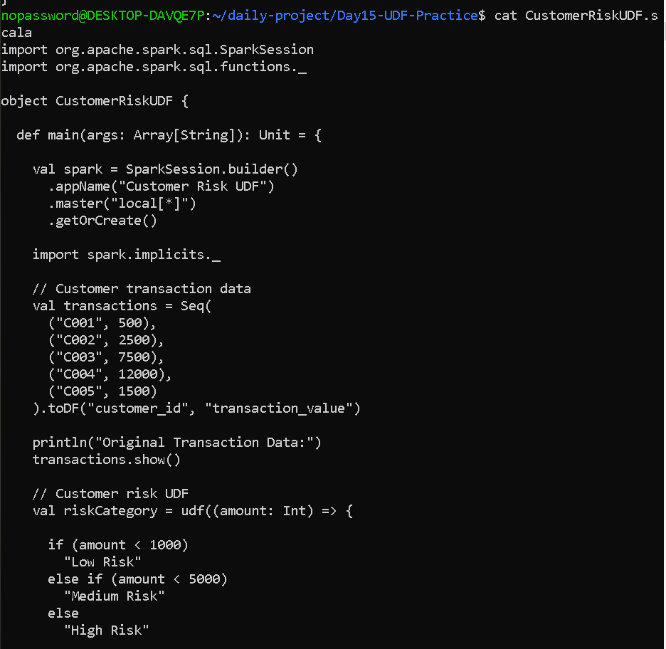

import org.apache.spark.sql.SparkSession
import org.apache.spark.sql.functions._

object CustomerRiskUDF {

def main(args: Array[String]): Unit = {

val spark = SparkSession.builder()
.appName("Customer Risk UDF")
.master("local[*]")
.getOrCreate()

import spark.implicits._

// Customer transaction data
val transactions = Seq(
("C001", 500),
("C002", 2500),
("C003", 7500),
("C004", 12000),
("C005", 1500)
).toDF("customer_id", "transaction_value")

println("Original Transaction Data:")
transactions.show()

// Customer risk UDF
val riskCategory = udf((amount: Int) => {

if (amount < 1000)
"Low Risk"
else if (amount < 5000)
"Medium Risk"
else
"High Risk"

})

// Add calculated risk_category column
val result = transactions.withColumn(
"risk_category",
riskCategory(col("transaction_value")))
println("Customer Risk Classification:")
result.show()
// Register UDF
spark.udf.register("customer_risk_udf", (amount: Int) => {

if (amount < 1000)
"Low Risk"
else if (amount < 5000)
"Medium Risk"
else
"High Risk" })

// Register DataFrame as temporary SQL view
transactions.createOrReplaceTempView("transactions")

// Execute SQL using registered UDF
val sqlResult = spark.sql("""
SELECT
customer_id,
transaction_value,
customer_risk_udf(transaction_value) AS risk_category
FROM transactions""")

println("Risk Classification using Spark SQL:")
sqlResult.show()
spark.stop()}}

OUTPUT—
sbt "runMain SalaryUDF"
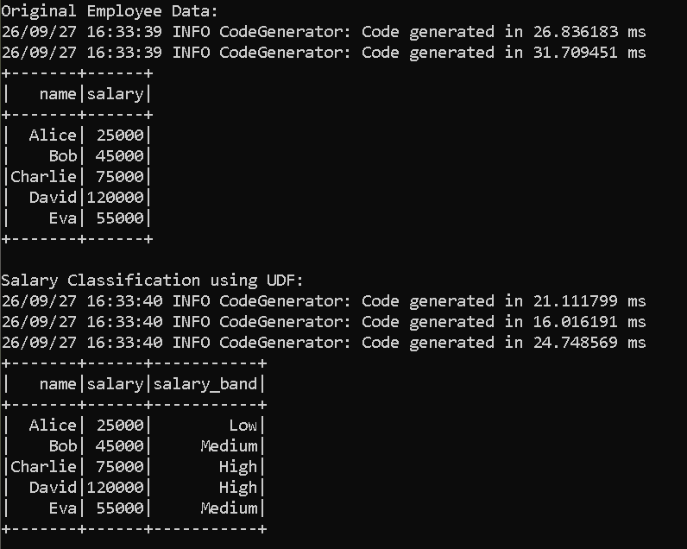

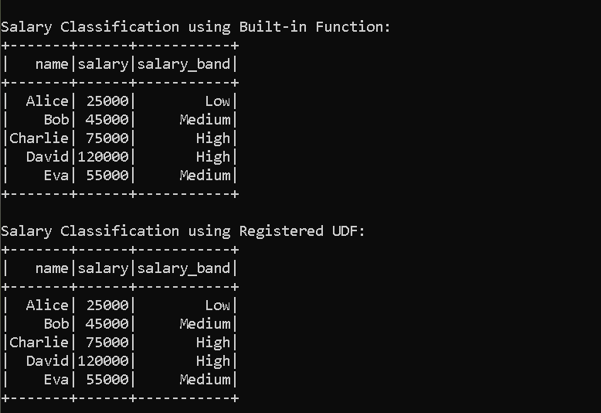

sbt "runMain CustomerRiskUDF"
